KENYA GROUP 1: SUMMARY 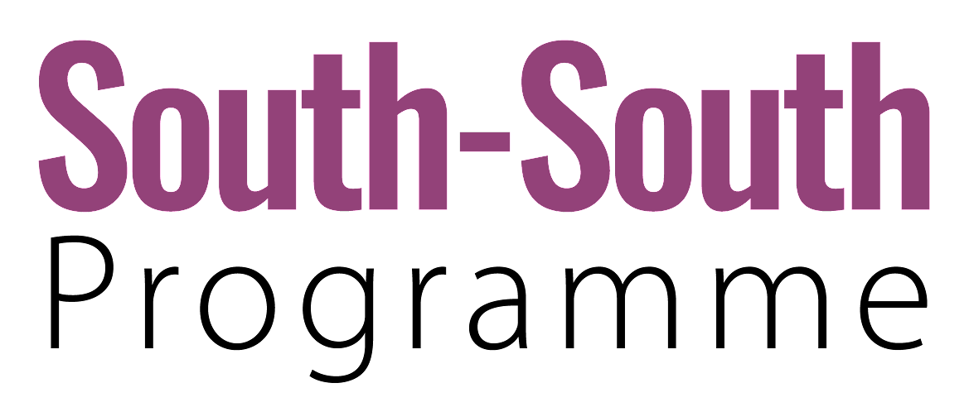
SCALE OF OUTCOMES |  |  |  |  |  | A lasting shift at all four levels causes sustainable changes in the landscape  ↓  SYSTEM TRANSFORMATION  AT THE NATIONAL LEVEL
SCALE OF OUTCOMES | Landscapes |  |  | New structures are aligned with new practices, approaches, narratives, and mental models and adopted at a broader scale so enabling conditions become further embedded in the system.  ↓  SYSTEM TRANSITION |  | Students acquiring 21st century skills beyond foundational learning (the model reverberates)
SCALE OF OUTCOMES | Culture |  | A critical mass of mutually reinforcing and effective innovations can be supported and escalated to influence structures and/or cultures, causing a shift in conditions that hold a problematic situation in place.  ↓  SYSTEM SHIFT |  | Culture of innovation: multiplier effect takes hold | 
SCALE OF OUTCOMES | Structures |  | New or adapted responses and solutions are incubated within protected spaces.  ↓  NICHE INNOVATIONS | Kirinyaga becomes a model that is expanded to other regions of the country
 | Niche innovations |  | Kirinyaga actions/innovations for foundational learning: "leaving no learner behind"
Agency, capability, understanding
TIME

KENYA GROUP 1: MORE DETAILS

NICHE INNOVATIONS | SYSTEM SHIFT | SYSTEM TRANSITION | SYSTEM TRANSFORMATION  AT THE NATIONAL LEVEL
- Adapted responses in Kirinyaga:  - Working together: government, teachers, unions, coalition representatives, are all aligned in focusing on literacy at the right age and agree they need to move forward  - Partners from the South-South have joined, but the people are in charge of the implementation  - We want to train teachers and the officers on the ground to be trained to also document and disseminate their story  - We are looking at co-creating learning resources between teachers in the classroom and KICD the government agency  - Spirit of collaboration and shared learning  - Together, identify the problem with the citizens, local leadership, school leaders and teachers to try and understand the current state of FLN. Locally led  - Monitoring teaching and learning | - If Kirinyaga succeeds:  - It will strengthen the actors that have come together in it to expand the knowledge and learning they have gathered there to other parts of the country since they have come from different regions  - Involvement of teachers in early years in capacity building.Research has continuously indicated that children are not learning.we want to address the problem right from the bottom  - Resource diversity ensures that the instructional materials take care of different categories of learners  - Risk identification and mitigation matrix  - Define the presence and role of stakeholders in the expansion so they are all actively involved  - Staff development: training for teachers, capacity building, diverse approaches  - Changes on how to recruit people in schools and train them | - Expected cultural changes:  - Success has a way of becoming the norm - everyone wants to try something that worked (culture of innovation spreading, more actors in the sector wanting to try)  - People have been settled in their ways, so if this succeeds we will get people out of their comfort zone and willing to try different things to improve learning outcomes  - Quality of learning at the formative and summative evaluation  - Teacher empowerment  - Having more proactive leaders  - Students have more self-confidence, parents trust the educational system more: they accompany their children to school, find out about their progress  - People trying to find and having believe in their own local projects to improve education  - Budgets for education increase since results show that it works - leadership will look at education in a different way  - Money for their investment = more input  - Locally driven solutions. The local (school) leaders are instrumental in the transition - to accepting on the change that works.  - Spaces for collaboration will grow and become the norm | - Expected results in the landscape:  - Sustained progress over time  - % of committed students, parents and teachers  - Policy aspects:  - % of teacher training  - Material development  - Students will have acquired 21st century skills: critical thinking, problem-solving, digital literacy, citizens of the world  - A structured model where parents and school leadership as well as learners engage continuously for the improvement of foundational learning.  - Foundational learning will be impacted beyond literacy (school leaders are critical)  - Multiplier effects: expect the same good results to flow to other levels (beyond foundational learning) / regions / countries: ​​change a system and not just foundational learning  - When the learners are ready for learning,emotionally and socially settled into learning ,the other levels will gain a flow  - X  - X  - X  - X  - X  - X  - X  - X  - X  - X  - X  - X  - X  - X  - X  - X  - X  - X  - X  - X

FIVE LEVELS OF CHANGE

To inform how we design our interventions to contribute to impact in the world, the Reos theory of change considers five levels:

1. Landscapes
The landscape is the level of the ultimate purpose of a systemic initiative: for example the actual carbon emissions, biodiversity levels, poverty trends, justice needs met, nutrition levels, violent conflict, etc. This is the space of human needs and planetary boundaries, the domain of shifting trends and bending curves. It is also the context in which an initiative takes place and which needs to be navigated.

2. Culture
Culture is the level of narratives, identities, values and paradigms. It shapes the lenses through which we observe and interpret the world. Our systems and structures are embedded in and reproduced by culture.

3. Structures
Systemic structures are the level of rules of the game – policies, institutions, processes, practices, power structures, resource flows, and infrastructures. They generate conditions that keep problematic situations in place and create constraints and opportunities for innovation.

4. Niche Innovations
Niche innovations provide new or adapted responses or ways to remove obstacles that hold a problematic situation in place. Niches are protected spaces where innovations can be incubated. The system provides the enabling environment or not for these innovations to scale. A critical mass of mutually reinforcing and effective innovations can be supported and scaled to influence systems and culture.

5. Agency and Capability
The inner transformation of agency (i.e. confidence, commitment) and the capacity (e.g., knowledge, awareness, skills, resources, power) of social innovators, changemakers, and system leaders enhances their ability to address problematic situations. This applies individually and collectively (e.g. at the level of teams, organizations, networks). The collective level involves the depth of trust, connection, shared understanding, and collaborative practice.

REOS THEORY OF CHANGE

The Reos theory of change illustrates our understanding of how change happens in the world, within complex adaptive systems.

This diagram is not a depiction of a singular, linear narrative of change. Rather it is intended to offer a language for strategic conversations about outcomes, contributions, synergies, and complementarities in systems change initiatives and to inform design of interventions.

It draws on work from the Reos Partners evaluation team with inspiration from Mark Cabaj of Here to There consulting and the work of Frank W. Geels.

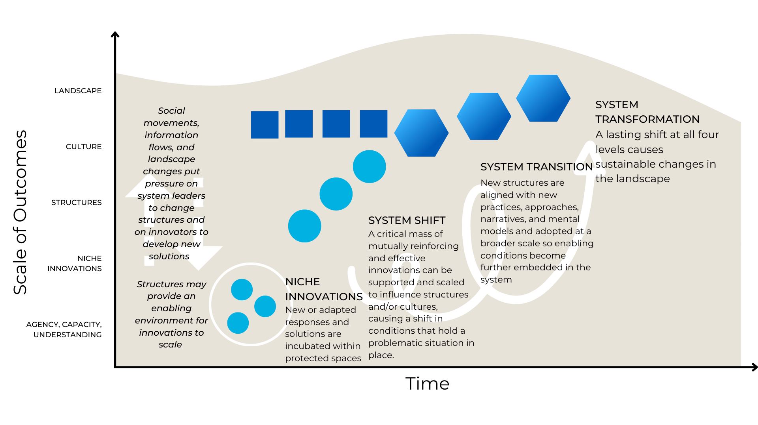
CUMULATIVE IMPACT IN SYSTEMS CHANGE

The cumulative impact scale illustrates increasing extent of ambition and impact. This is not a linear process.

RESULTS THAT MAY BE ATTRIBUTABLE TO AN INITIATIVE |  |  | RESULTS AN INITIATIVE CONTRIBUTES TO
AGENCY, CAPACITY & UNDERSTANDING | NICHE INNOVATIONS | SYSTEM SHIFT | SYSTEM TRANSITION | SYSTEM TRANSFORMATION
Increase in the agency, capacity, relationships, commitments, and understanding of innovators and other stakeholders to be able to address a problematic situation. | A portfolio of new or adapted responses that stakeholders develop or adapt and implement to address a problematic situation. | Promising changes are institutionalized in the system, catalyzing a shift in the structural and/or cultural conditions (systemic drivers) that hold the problematic situation in place. | New practices, approaches, and structures are adopted at a broader scale and rooted in shared narratives, values, mental models. Enabling conditions become further embedded in the system through alignment and mutual reinforcement between structure and culture. | A lasting shift at all four levels (capacity, innovation, structure, and culture) contributes to changes in the landscape. This is mission-level impact.

