KENYA GROUP 2: SUMMARY 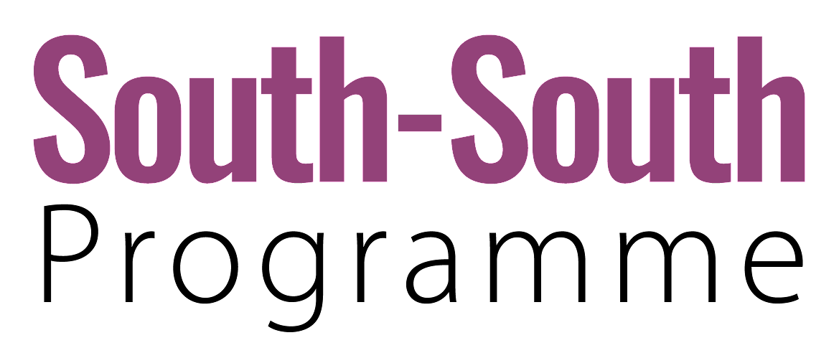
SCALE OF OUTCOMES |  |  |  |  |  | A lasting shift at all four levels causes sustainable changes in the landscape  ↓  SYSTEM TRANSFORMATION  AT THE NATIONAL LEVEL
SCALE OF OUTCOMES | Landscapes |  |  | New structures are aligned with new practices, approaches, narratives, and mental models and adopted at a broader scale so enabling conditions become further embedded in the system.  ↓  SYSTEM TRANSITION |  | Model to upscale the project. Broad guidelines on deployment of teachers and assessment adopted across the country. Emergence of guidelines to promote collaboration across counties and nationally for smooth transition between pre-primary and primary schools.  Change in how teachers are trained.
SCALE OF OUTCOMES | Culture |  | A critical mass of mutually reinforcing and effective innovations can be supported and escalated to influence structures and/or cultures, causing a shift in conditions that hold a problematic situation in place.  ↓  SYSTEM SHIFT |  | Standardized assessment across county making all ECD schools have the same standards.  Teacher deployment practices fully aligned to the needs and attitudes for early grade learning. | 
SCALE OF OUTCOMES | Structures |  | New or adapted responses and solutions are incubated within protected spaces.  ↓  NICHE INNOVATIONS | Transforming teacher deploying policies, making best teacher go to lower levels of learning.  Change assessment practices making them more aligned with what is actually being taught in schools and supporting teaching and learning.
 | Niche innovations |  | Structured pedagogy for foundation learning. Teachers motivated, equipped and facilitated to assess children, facilitate remedial sessions and adapt teaching and learning to have all children reading by the end of grade 3.
Agency, capability, understanding
TIME

KENYA GROUP 2: MORE DETAILS

NICHE INNOVATIONS | SYSTEM SHIFT | SYSTEM TRANSITION | SYSTEM TRANSFORMATION  AT THE NATIONAL LEVEL
- Based on Sobral experience  - At least 90% of children reading by grade 3  - Actors involved: Ministry of Education at local level, teacher’s service commission, Ministry of Education of Kirinyaga  - Partners  - Pilot with teachers and school, public and private  - Upon success, scale up to the national level  - Innovations: best teachers moved to lower grades, catch up methodology to support children to learn at the right level, every child are able to read, based on assessment  - Change in attitude, no child with reach grade 4 without literacy and numeracy  - What are skills sets needed by teachers to improve learning?  - Establishing classroom based assessment for teaching and learning  - Formative assessment and individual learners focus | - [Write here] | - [Write here] | - [Write here]  - X  - X  - X  - X  - X  - X  - X  - X  - X  - X  - X  - X  - X  - X  - X  - X  - X  - X  - X  - X  - X  - X  - X  - X  - X  - X  - X  - X

FIVE LEVELS OF CHANGE

To inform how we design our interventions to contribute to impact in the world, the Reos theory of change considers five levels:

1. Landscapes
The landscape is the level of the ultimate purpose of a systemic initiative: for example the actual carbon emissions, biodiversity levels, poverty trends, justice needs met, nutrition levels, violent conflict, etc. This is the space of human needs and planetary boundaries, the domain of shifting trends and bending curves. It is also the context in which an initiative takes place and which needs to be navigated.

2. Culture
Culture is the level of narratives, identities, values and paradigms. It shapes the lenses through which we observe and interpret the world. Our systems and structures are embedded in and reproduced by culture.

3. Structures
Systemic structures are the level of rules of the game – policies, institutions, processes, practices, power structures, resource flows, and infrastructures. They generate conditions that keep problematic situations in place and create constraints and opportunities for innovation.

4. Niche Innovations
Niche innovations provide new or adapted responses or ways to remove obstacles that hold a problematic situation in place. Niches are protected spaces where innovations can be incubated. The system provides the enabling environment or not for these innovations to scale. A critical mass of mutually reinforcing and effective innovations can be supported and scaled to influence systems and culture.

5. Agency and Capability
The inner transformation of agency (i.e. confidence, commitment) and the capacity (e.g., knowledge, awareness, skills, resources, power) of social innovators, changemakers, and system leaders enhances their ability to address problematic situations. This applies individually and collectively (e.g. at the level of teams, organizations, networks). The collective level involves the depth of trust, connection, shared understanding, and collaborative practice.

REOS THEORY OF CHANGE

The Reos theory of change illustrates our understanding of how change happens in the world, within complex adaptive systems.

This diagram is not a depiction of a singular, linear narrative of change. Rather it is intended to offer a language for strategic conversations about outcomes, contributions, synergies, and complementarities in systems change initiatives and to inform design of interventions.

It draws on work from the Reos Partners evaluation team with inspiration from Mark Cabaj of Here to There consulting and the work of Frank W. Geels.

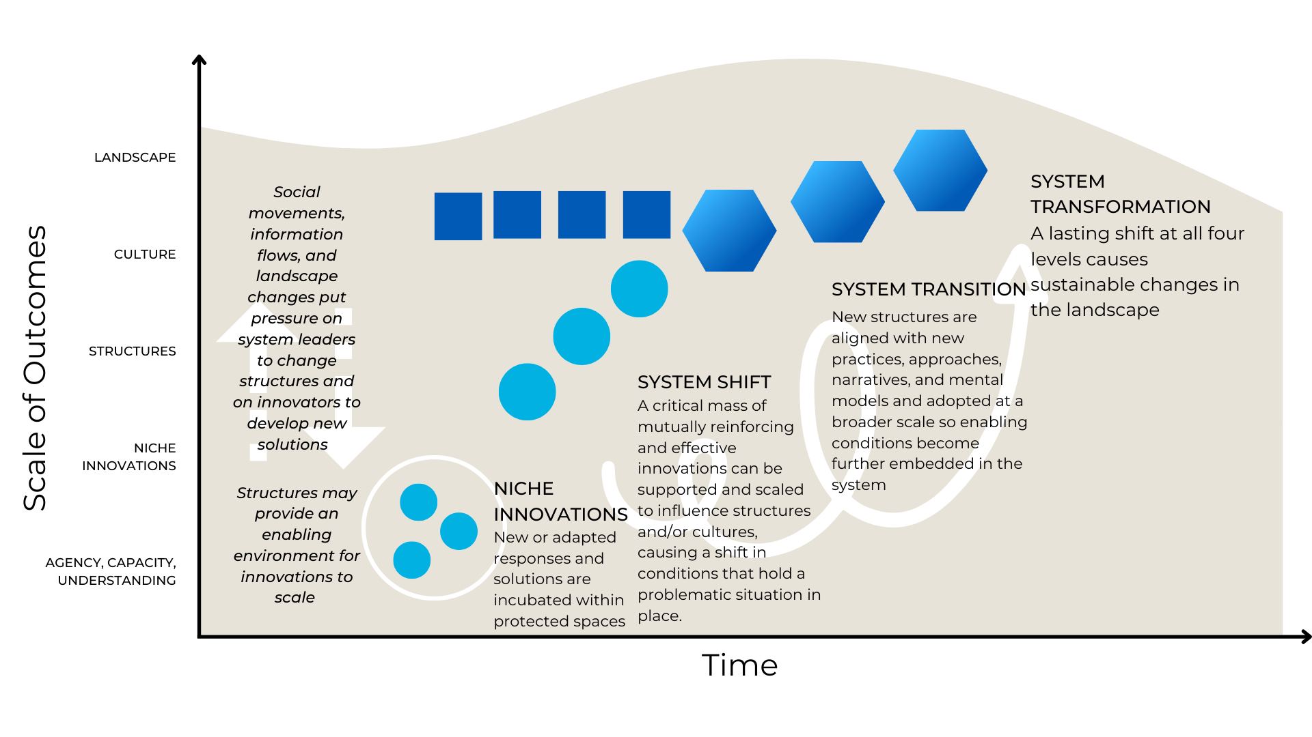
CUMULATIVE IMPACT IN SYSTEMS CHANGE

The cumulative impact scale illustrates increasing extent of ambition and impact. This is not a linear process.

RESULTS THAT MAY BE ATTRIBUTABLE TO AN INITIATIVE |  |  | RESULTS AN INITIATIVE CONTRIBUTES TO
AGENCY, CAPACITY & UNDERSTANDING | NICHE INNOVATIONS | SYSTEM SHIFT | SYSTEM TRANSITION | SYSTEM TRANSFORMATION
Increase in the agency, capacity, relationships, commitments, and understanding of innovators and other stakeholders to be able to address a problematic situation. | A portfolio of new or adapted responses that stakeholders develop or adapt and implement to address a problematic situation. | Promising changes are institutionalized in the system, catalyzing a shift in the structural and/or cultural conditions (systemic drivers) that hold the problematic situation in place. | New practices, approaches, and structures are adopted at a broader scale and rooted in shared narratives, values, mental models. Enabling conditions become further embedded in the system through alignment and mutual reinforcement between structure and culture. | A lasting shift at all four levels (capacity, innovation, structure, and culture) contributes to changes in the landscape. This is mission-level impact.

